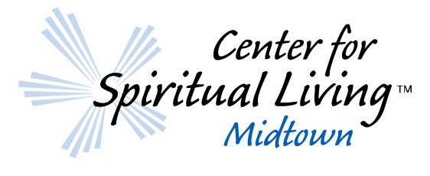

You’re Invited

Become a CSL Midtown Sustaining Member
Automatic Donations: Go to www.CSLMidtown.org and click on “Donate Now” to set up your automatic scheduled contribution. Then, complete the Pledge Information below and return it to us. Where the web form says “Fund”, select “Committed Giving” in the dropdown box. Then select “Give Multiple Times” and establish your preferred schedule.

Checks: Complete the Pledge Information below and return it to us.

Ways to Contact Us: Email Info@cslmidtown.org or mail CSL Midtown, 1700 Northside Dr, Ste A7 PMB 2397, Atlanta GA 30318.

My intention for financial support of CSL Midtown:
I choose to celebrate prosperity. Divine Love blesses my gift. It is my acceptance of God as the Source of my abundant supply. With joy and gratitude, I share my abundance with this Center. In doing so, I am one with the law of circulation. My pledge goes forth to heal, to prosper and to bless. It returns to me multiplied abundantly, and I am prospered — and so it is!

I will:
- Enter this information online in our Donate Now form, or
- Deposit this amount into the offering basket
Name __________________________________________
Telephone _______________________
Address ______________________________________________________________________________
Email __________________________________
As a celebration of my prosperity, I joyously offer my intention of:
- $______ Month
- $______ Week
- $______ Lump Sum

Thank you for your ongoing support!

